USER GUIDE

System Administration

September 2018

Version 1.02

Pharmacon ITC303/309 Group

Document Revisions

|  |  |  |
| --- | --- | --- |
| Date | Version Number | Document Changes |
| 31/08/2018 | 1.01 | Draft |
| 15/09/2018 | 1.02 | Initial |
|  |  |  |
|  |  |  |
|  |  |  |
|  |  |  |
|  |  |  |
|  |  |  |
|  |  |  |

Table of Contents

1 Introduction 4

1.1 Scope and Purpose 4

1.2 Prerequisites 4

2 System Configuration 5

2.1 Configure MySQL 5

2.2 Configure PET Settings 5

3 Software Installation 6

3.1 Build Server 6

4 Managing the Server 9

4.1 Starting the Web Server 9

4.2 Starting the Metabase Report Server 9

4.3 Stopping the Web Server 9

4.4 Stopping the Metabase Report Server 9

# Introduction

## Scope and Purpose

The purpose of this user guide is to provide instructions on how to install and configure your server so that you will be able to deploy the Pharmacy Error Tracker (PET) software in your environment.

* This feature is only available to a user with sudo rights on Ubuntu.

NOTE: Only users with an intermediate or higher level of knowledge in Linux should be using this guide.

## Prerequisites

For the PET software to be installed the following minimum requirements are suggested for your server infrastructure:

* 2 core CPU
* 4GB Ram
* 9GB Storage
* Ubuntu 16.04.4 LTS

To successfully install the PET system, you will need to following items installed on your Ubuntu server:

* GIT
* JAVA 1.8 or greater
* NODEJS 9.10 or greater
* MySQL 5.7.22 or greater

Finally, the following ports need to be open and available for the PET software to function correctly:

* 17050 – Metabase Report Server Port
* 3306 – MySQL Port
* 3000 – Pharmacon Application Port

# System Configuration

## Configure MySQL

As part of the PET software installation the software uses several tables in the MySQL database to store and retrieve data relating to errors, users, and medications that are going to be tracked by the system. To create these tables, the PET software comes with a simple SQL script that can be run on your database to create the Schema and tables required.

To execute the PET SQL script, use the following command replacing the MySQL login details with your own MySQL user credentials:

1. cd ~/*pharmacy_app/code/Database PET*
2. *mysql -u <username> -p < PETDatabaseScriptV2.sql*

Once this has been completed your MySQL database will now have to correct schema and database tables setup.

## Configure PET Settings

Now that you have successfully set up the MySQL database, the PET software application requires your database credentials to connect to the MySQL database so that it can read and write data.

To update the environmental configuration file for the PET software application run the following commands:

1. cd ~/*pharmacy_app/code/server*
2. *vim .env*

You will now need to update the following entries:

1. DB_USER: This is the username for your MySQL instance, the default value is root
2. DP_PASS: This is the password for your MySQL instance, the default value is pharmac0n

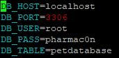

Example: .env file settings

# Software Installation

## Build Server

The System Administrator will need to log into PET server using putty or other preferred SSH agent as well as their valid username and password or SSH keys.

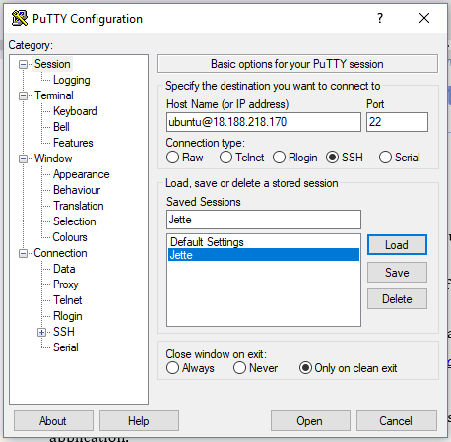

* The terminal window will be presented on successful login.  
  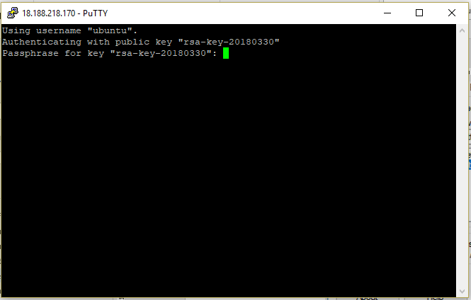  
  Enter your login for Putty at this point.  
  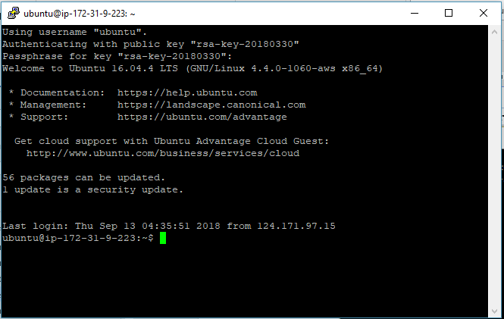

Once the user has logged in from the root directory (~) the user needs to clone the PET application from bitbucket by running the following command:

git clone <https://bitbucket.org/itc303teampharmacon/pharmacy_app.git>

The System Administrator will need to use their credentials to sign in and clone the PET application.

Once the file has been downloaded the following command needs to be run in order to give permissions to run the required setup scripts in manual:

*sudo chmod 777 pharmacy_app/scripts/buildserver.sh*

To configure the server for use, the user needs to run the following commands on the server:

1. *cd pharmacy_app/scripts/*
2. *./buildserver.sh build-server*

These commands will setup the configuration files as required and will create the server aliases that will be required to start the different aspects of the server.

# Managing the Server

## Starting the Web Server

To start the web server, now that the server has been built, the user can run the following command in the console to start the Web Server component of the PET application:

*pharmacon start-webserver*

## Starting the Metabase Report Server

To start the Metabase reporting server now that the server has been built, the user can run the following command in the console to start the Metabase Reporting Server component of the PET application*:

pharmacon start-metabase

* Please note that if the user has already started the Web Server in the terminal, they will need to make a new terminal session to the server to run the Metabase Reporting Server.

## Stopping the Web Server

To stop the web server now that the server has been built, the user can run the following command in the console to stop the Web Server component of the PET application:

*pharmacon stop-webserver*

## Stopping the Metabase Report Server

*To stop the Metabase reporting server* now that the server has been built, the user can run the following command in the console to *stop* the *Metabase Reporting Server component of the* PET application*:*

pharmacon stop-metabase